Data Mining Proposal
Job-hopping or Job-Hugging, what brings in top talent and makes them stay
Team Solo Pilotbear
Project midterm review
Date: March 21, 2026

In this project, we are interested in utilizing data analytics approach in discovering the science behind employee attrition at workplace, levering binary classification algothrims, employ machine learning such as FP-growth techniques to identify the secret sauce of what makes employee stay and turnover.

Let us first look at a simple analysis and see, at the raw data level, how overtime can impact the employee attrition. It turns out, consistently overtime is a driver to make the employee rethink the employment and push to make changes. Employees that have consistently experienced overtime are 3 times more likely to leave than their peers that do not.

As a business, overtime can happen, we understand that sometimes a project, a presentation, or an urgent meeting can take place. However, employers should not make a habit out of this; overtime should be exceptions, in extraordinary circumstances, and rarely utilized. Please make “on-time” the overwhelmingly expectation and experience, and your employees is more likely to stick around and share the growth together.

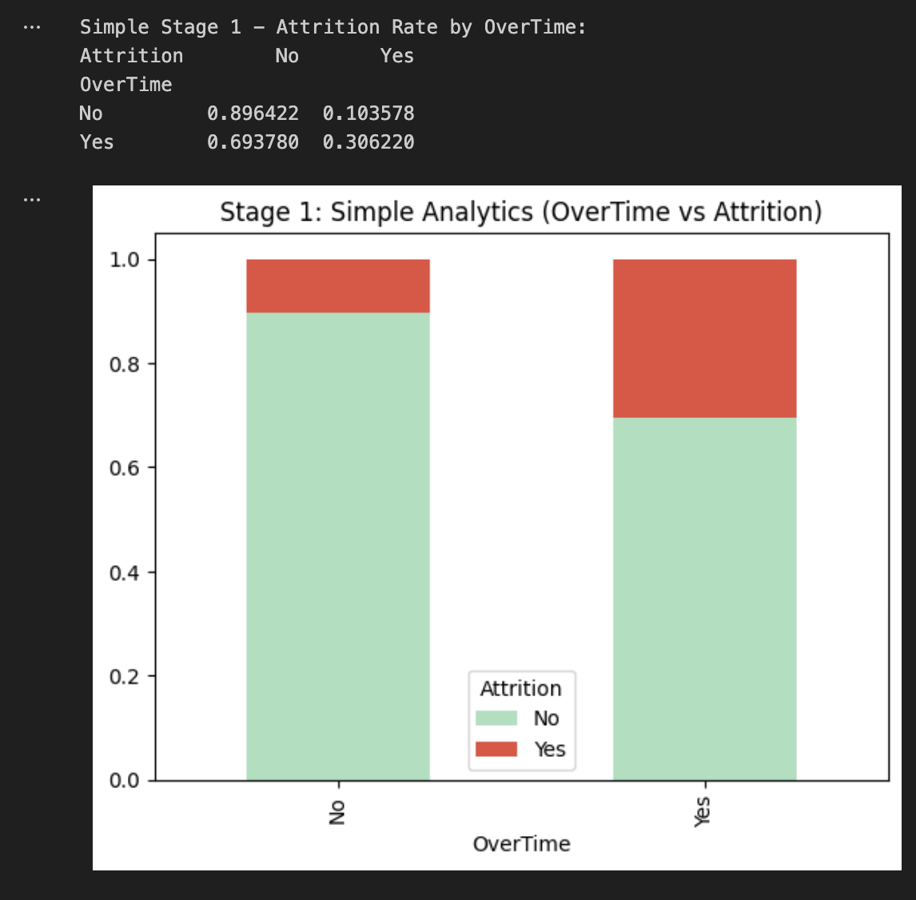

Next up, we have more detailed analysis that goes beyond one simple factor “overtime”. We take into account a number of varibles and is able to pick the top 5 that mattered the most:
Monthly Income, the higher the income the more likely the employee to stay, this is true not only because of the monetary rewards to the employee, it also indicates that, as the knowledge, experience, and expertise grow, the employee is moving to a niche marketplace and is harder to find an exact position that requires the exact skillsets. It also indicates that the number of openings shrinks as the employee progresses.
Age plays a significant part too. Young professionals (age < 30) has a higher mobililty, for a number of reasons:
They are in the early stages of finding out what they are good at and is hungry for promotions. In some areas and some times, job hopping rewards the early-stage careers to change the job, at a higher frequency. Another reason is that, young people are more likely to not be bounded by family, they have a great mobility in the workplace.
Overtime, as we covered in the last section, plays a big part too. And we will not repeat ourselves here.
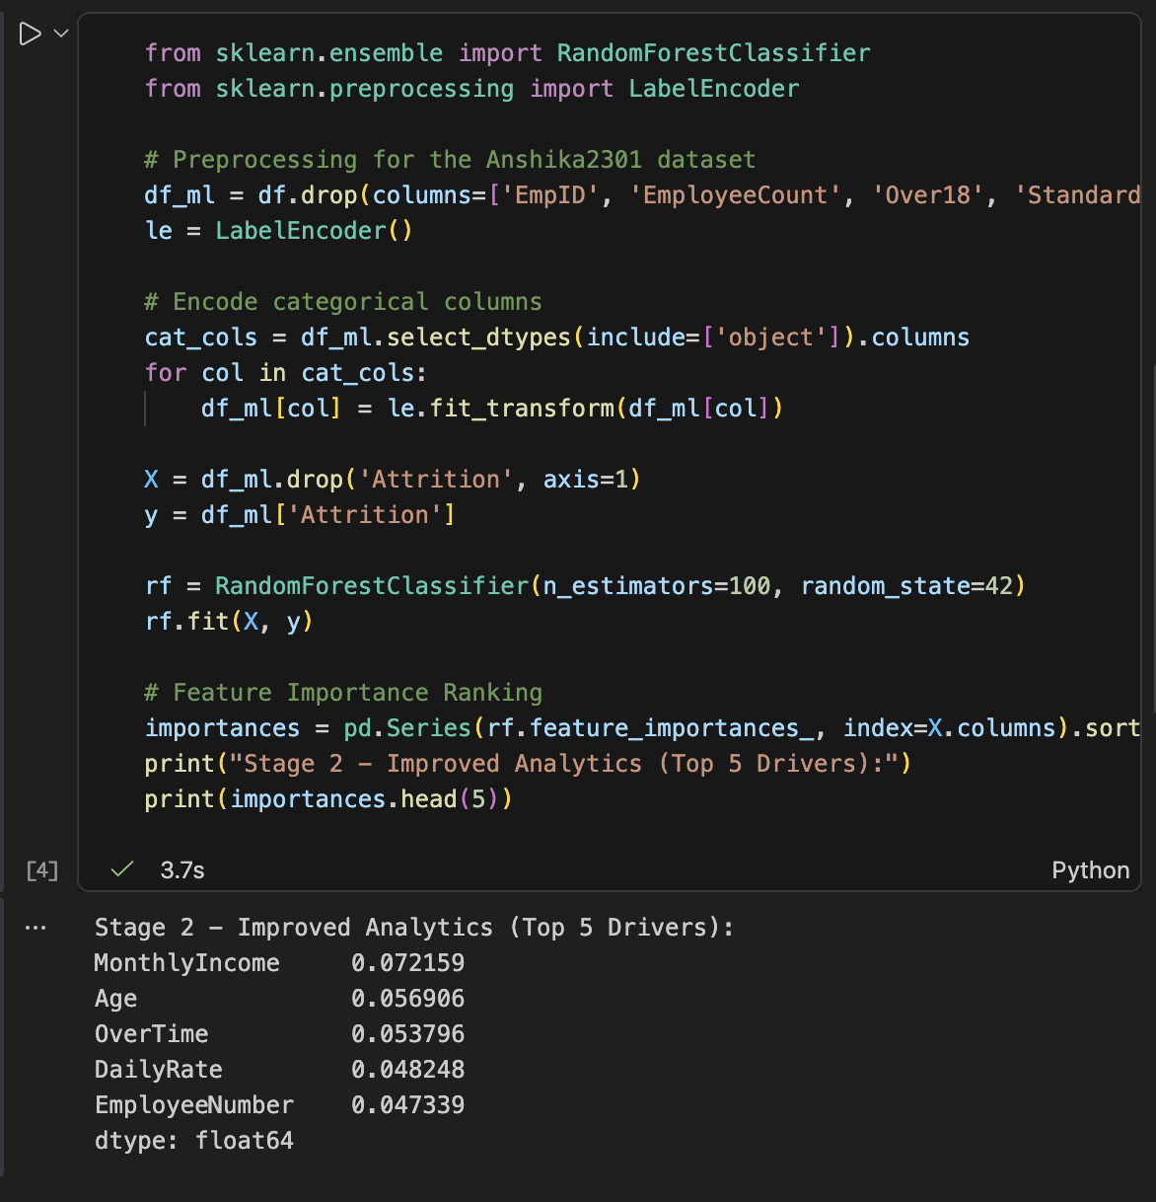
We now turn our attention to association rules that go beyond classficiation. We can see employees who work overtime, and has Low monthly income, and are single are more likely to attrition than their peers.
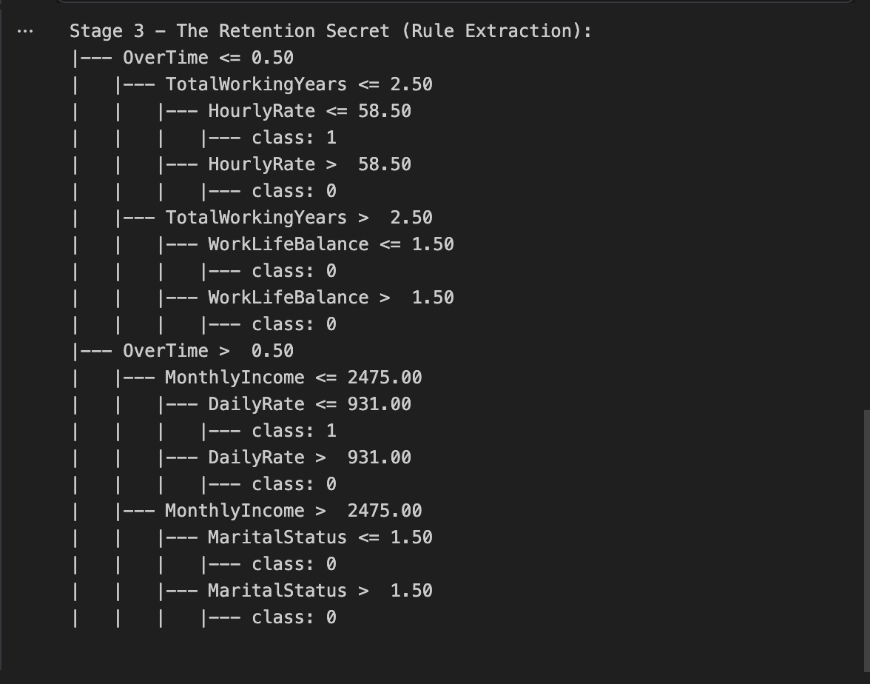

Some of the problems and future directions: I tried to implect Aprior and FP-growth into the analysis but it is little more tricky than I anticipated and is currently working on resovle the issues. Hopeful to be able to produce the results soon.
Addtionally, a back testing schema is being considered and hopefully will be able to work it out when the final project is due.

